Task 3: SQL Data Exploration and Analysis Using Dataset 2

Step 1: Database and Table Setup
Objective: To create a separate database and verify the table structures for the spacecraft communication dataset.
Database Name: space_communications
Tables Used:
- spacecraft — stores spacecraft names, targets, agencies, launch dates, and statuses.
- communication_logs — stores ground-station details, communication dates, signal strengths, and transmission durations.
SQL Concepts Used: CREATE DATABASE, USE, CREATE TABLE, SHOW TABLES, DESCRIBE, primary keys, and foreign keys.
Observation: The database and table structures were created and checked in MySQL Workbench. The spacecraft_id foreign key connects communication records to their corresponding spacecraft.
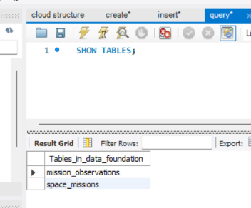

Step 2: Data Loading and Verification
Objective: To populate the spacecraft and communication-log tables and verify that the records were inserted correctly.
SQL Concepts Used: INSERT INTO, VALUES, SELECT, and COUNT().
Data Loading Performed:
- Inserted 8 spacecraft records into the spacecraft table.
- Inserted 10 communication records into the communication_logs table.
- Retrieved the inserted records and checked the total row counts.
Result: The database contains 8 spacecraft records and 10 communication-log records.
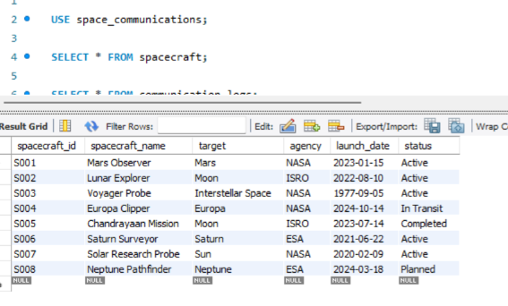
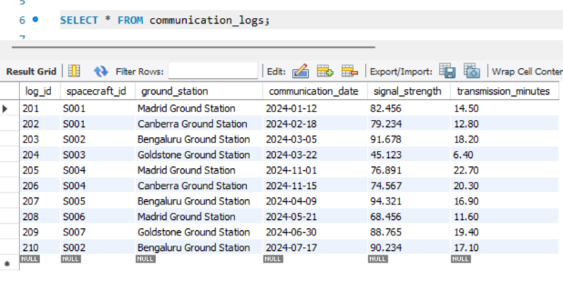

Step 3 :
Query 1: Pattern-Based Filtering and Result Limiting
Objective: To identify spacecraft whose names contain the word "Probe" and display the matching records in descending launch-date order.
SQL Concepts Used: LIKE, WHERE, ORDER BY DESC, and LIMIT.
Purpose: The query searches for spacecraft names containing a specified text pattern, sorts the matching records by launch date, and limits the output to five records.
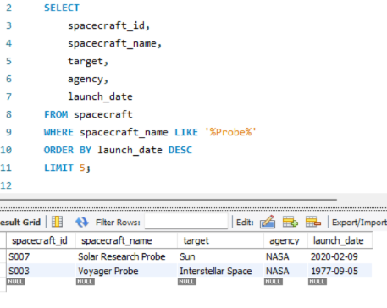
Query 2: Range-Based Filtering
Objective: To retrieve communication records whose signal strength falls between 75 and 90.
SQL Concepts Used: WHERE, BETWEEN, and ORDER BY DESC.
Purpose: The query filters communication logs using a specified signal-strength range and sorts the matching records from highest to lowest signal strength.
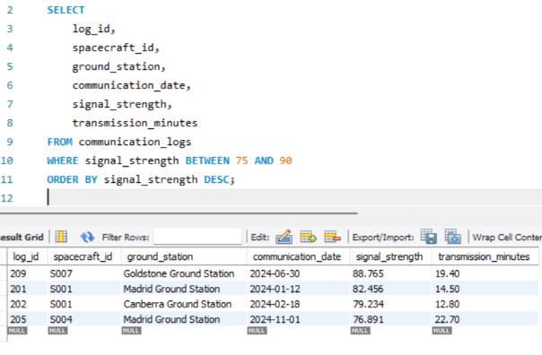

Query 3: Combining Related Tables Using LEFT JOIN
Objective: To display all spacecraft along with their communication records, including spacecraft without any communication logs.
SQL Concepts Used: LEFT JOIN, ON, table aliases, and ORDER BY ASC.
Purpose: The query combines the spacecraft and communication_logs tables using the common spacecraft_id column. Unlike an INNER JOIN, a LEFT JOIN retains every spacecraft from the left table, even when no matching communication record exists.

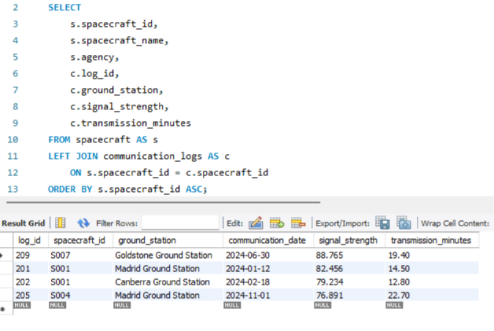

Query 4: Rounded Aggregate Analysis
Objective: To compare average communication signal strength across space agencies.
SQL Concepts Used: LEFT JOIN, COUNT(), AVG(), ROUND(), GROUP BY, and ORDER BY DESC.
Purpose: The query joins spacecraft details with communication records, groups the results by agency, counts the communication records, calculates the average signal strength, rounds the average to two decimal places, and sorts the agencies by average signal strength.
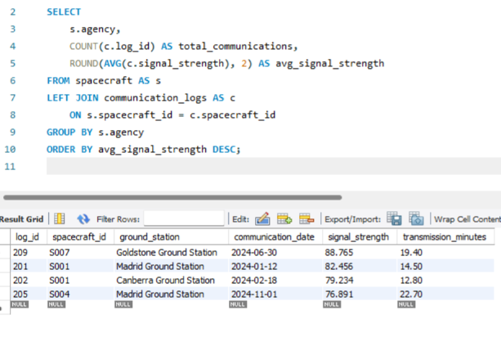

Conclusion :
The spacecraft communication dataset was stored in a separate MySQL database using two related tables: spacecraft and communication_logs. Four SQL queries were implemented to explore and analyse the data.
The queries demonstrated pattern-based filtering using LIKE, sorting and limiting results using ORDER BY and LIMIT, range-based filtering using BETWEEN, combining related tables using LEFT JOIN, and calculating rounded averages using AVG(), ROUND(), and GROUP BY.
These operations helped identify spacecraft matching a text pattern, filter communication records by signal strength, display spacecraft without communication logs, and compare average signal strength across space agencies.
Overall, the task provided practical experience in SQL filtering, joins, aggregation, and interpreting structured communication data.

